Identifing Ships Using Satellites Images

by Using Deep Learning Techniques

Tadavarthi Rukmini Gayathri  
 *Computer Science and Engineering*  
 *Narasaraopeta Engineering College*  Narsaraopeta rukminigayathri3@gmail.com

Dr. M.Sireesha , M.Tech., Ph.D

Assoc.Professor,Computer Science and Engineering

Narasaraopeta Engineering College

Narasaraopet, India

[moturisireesha@gmail.com](mailto:moturisireesha@gmail.com)

Meda Asritha   
 *Computer Science and Engineering*   
 *Narasaraopeta Engineering College*  Narsaraopeta  
 meda.asritha@gmail.com

Bandi Saiharsha

*Computer Science and Engineering*

*Narasaraopeta Engineering College*

Narasaraopeta

Saiharshabandi90@gmail.com

*Abstract*---When using remote sensing pictures for marine security, ship detection is essential. The deep learning method for identifying ships from satellite photos is covered in this research. In order to achieve integrity Hashing is included. This model makes use of a supervised method for classifying images, and then use You Only Look Once version 3 (YOLOv3) for object recognition and feature extraction from deep CNN. By using SHA-256 the ship count will be displayed.

KEYWORDS: remote sensing, deep learning, ship detection, YOLO v3, rel2bbox, SHA-256.

I INTRODUCTION

When compared with machines, Humans can identify objects however they are placed irrespective of size, shape and colour, while making machines to do same work requires a lot of energy and work. The YOLOV3 ML algorithm uses Deep CNN to detect objects located in the images. [12],[15]. Rel2bbox-The rel2bbox function is used to define the bounding boxes which helps us to spot the ships. It usually takes two parameters. The process is done pixel Co-ordinate, Width and Height respectively.

Satellite images are usually made up of large no of pixel which ranges from centimetres to meters. These Images are in the form of water vapour, Infrared, Visible. The modern YOLOV3 can identifies objects dynamically like in images, videos. And it underwent trained and tested on large data set .we use SHA-512 which maintains security for the transmission of data.

In this model I have used Kaggle’s ship detection dataset

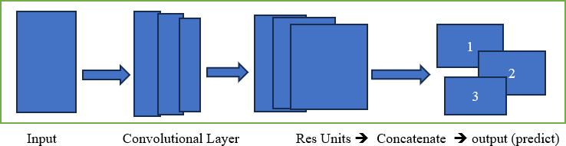which contains 2,30,000 photos .

Fig. 1. Process of how YOLOV3 detects objects in Images

# ***II LITERATRE SURVEY***

The following are the references that are taken for reference for this research paper as a part of literature survey. From these manuscripts we are ableto understand how an algorithm works and what algorithm needs to be used for the identification and structuring of bounding boxes.

Jeff Faudi et.al. [1] described a methodology where the identification of ships. The help of window- shielding method the input images which are large are broken down into small images. It can only identify one kind of ship. With the help of multilevel feature extraction, the accuracy increases as it helps to even detect small objects. The limitation is that (i) it cannot detect ship which are between sea and land (ii) if the image is too small then it will increase complexity. [11]

Redmon, J. et.al [2] implemented where the system works with the dpm and uses the window shield for the detection of objects. This method uses yolo to identify the images from a single convolutional layer from that the segmentation of the images is defined and with one look it can trace where the object is present and the imperfection is that it can provide security for the location identified by the model.

Hannennvik, T. N. [3] implemented the utilization of SAR images from radarsat-2 which helps us to identify how the identification is done and the analysis, reporting of the images is combined. It has divided the ships into two categories like class A and class B, when compared with class B class A ships are easily identified and it is vulnerable – detection probability is based on the time rate of the signals, does not work well if the ships are in land masking. [9]

Van de Sande, K. E. et.al [4] used the segmentation for searching images. As we know that if we know the location of object then only, we can identify where the object is present in that image. Here he has used the segmentation to identify different locations of the object so that out of them the model can choose the best cluster from the group of locations[8]

Nie Xin et al. [5] described a model where the automatic ship detection and counting of ships will be done and with the help of yolo the process is designed by adjusting and optimizing the parameters. It can be done with the images which are HSV colour histography and LBP target features the object detection and segmentation is done. [17]

***III PROPOSED SYSTEM***

Our proposed system for identification of ships mainly consists of the following steps:

(A) Dataset Preprocess

(B) Bounding Boxes

(C) Normalization

(D) Ship Count

(E) Bounding Boxes.

(F) Hashing Value.

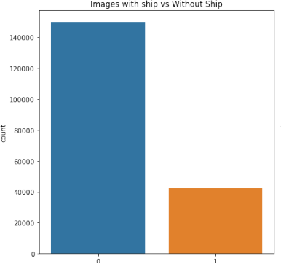

**(A)Dataset Preprocess:** is to load the data set which is Kaggle air bus ship detection and analyze the data set. With the help of pandas library, we have read the data set in which we came to know that the data set consists of 2 columns namely Image Id and Encoded Pixels.

(**B)Bounding Boxes**: To define the bounding boxes the bounding boxes can be defined by the help of rel2bbox function which takes two parameters those are rel and shape and it returns four values which are X coordinate, Y co-ordinate which defines the shape of the box, Width, Height.

**(C)Normalization:** To Normalize and drop - encode the bounding boxes. After defining the bounding boxes now we need to normalize the encoded pixels and the images which are normalized with the help of drop function from pandas we will remove the encoded pixels which has no bounding boxes the normalization.

### **(D) Ship Count:**This involves the visualization of the count of ships this is carried out as, first let us take a variable as count at first it is initialized to 0 and if the image has bounding boxes, then the count is going to be incremented by one and cross filter is going to be applied in order to protect the integrity of the algorithm. With the help of format specifier, the count of the ships is going to be visualized on top of the images.

### **(E) Bounding Boxes**:This to visualize the bounding boxes as we have already defined the bounding boxes now the function is going to be called and with the help of encoded pixel values the bounding box is going to be drawn and with the help of this, we will be able to identify the ships.

### **(F) Hashing Values** :The involves the hashing of the location of ships along with the count of ships. In order to provide the encoded value to these we have used SHA-512 function from the hash library. And it uses 512 bits and these are divided into 64 bytes and this encoded algorithm.

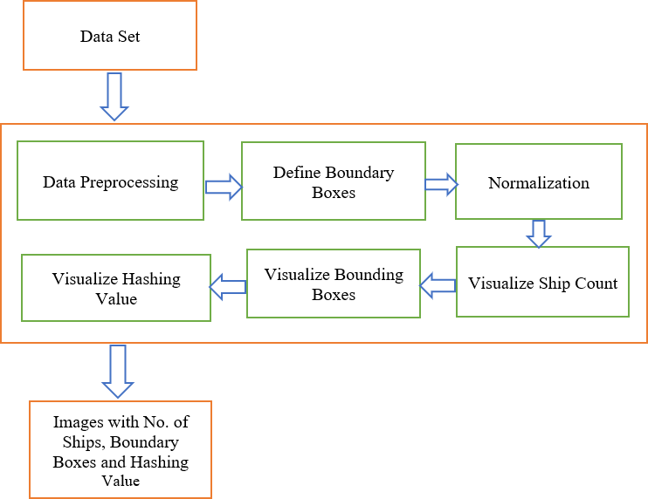

Fig .2. Proposed Methodology Architecture

Now we need find the find the area of the bounding boxes so that the area which is less than 1 percentile is removed and with the help of this we will able to identify the majority of ships size.

Fig .3.Images with Ship VS Without Ship

X-axis: bounding box width

Y-axis: bounding box height

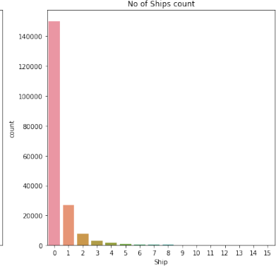Now we have identified how many ships are there in a image. Like the no. of images with 0 ships and the no. of images with 1 ship etc..

Fig .4. Number of ships in a image

X-axis: bounding box width

Y-axis: bounding box height

The Fig.4 shows the images that have at least one image. Here we have tried to find out whether satellite images have at least one image.

If there is no image then we are trying to remove the data of images which don’t have ships in them so that data gets simplified.

***PERFORMANCE ANALYSIS***

**Confusion Matrix**:

Confusion matrix helps us to understand how well our model performs on the data set.This shows the count of accurate and inaccurate model based on actual outcome.

It is primarily made up of four distinct components:

True-Positives: are instances in which the model accurately forecasts a positive class, such as when the ship is present and detected.

True-Negatives: when the model accurately forecasts a negative class in the absence of the ship

False-Positives: These occur when the model forecasts the positive class inaccurately, even when the ship is actually present.

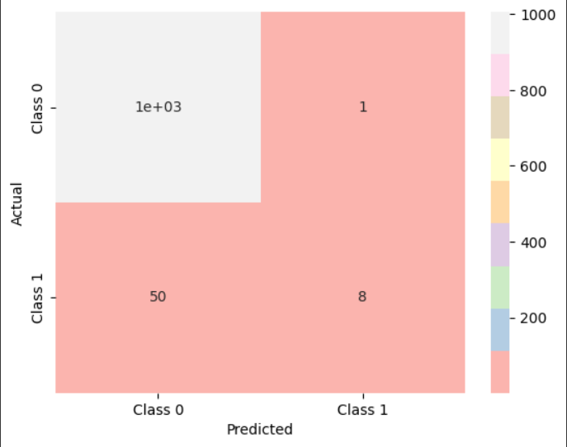 False-Negatives: When the ship is absent while the model predicts it to be present, this leads to an inaccurate negative class prediction.

Fig .5. Confusion Matrix of the data set

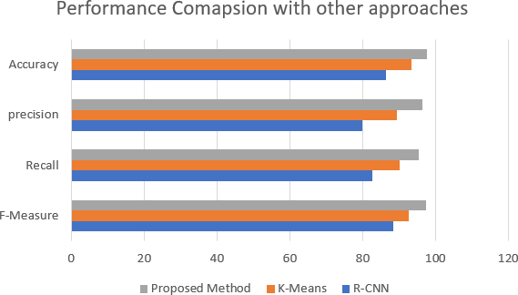While building this model we have also compared with other approaches like R-CNN and K-means in means of accuracy, precision, F1-Score, Recall out which if R- CNN gives an overall accuracy of 89% and K-Means g

Fig.6.Performance Comparison with other approaches.

# **Accuracy:**

Accuracy is used to calculate the performance of a algorithm. Classified instances are measured correctly among all the instances in the test dataset.

From the confusion matrix when can calculate the accuracy it can be done by the formula of sum of true-positive (NTP) and true-negative (NTN) divided by sum of true-positive (NTP), true-negative (NTN), false- positive (NFP) and false-negative (NFN).

Accuracy = (NTP+NTN)

---------------------

(NTP+NTN+NFP+NFN)

## **Recall:**

Recall usually know as sensitivity. It is the measure of correctly identifying the true positives, or predicting correctly from the true positive cases. IT can be calculated by using following formula,

Recall = NTP

--------------

(NTP+NFN)

### **Precision:**

Precision states that out of all the positive identification what are actually correct or at what level of the data that is predicted to be positive are actually positive. It is evaluated by the formula.

Precision = NTP

--------------

(NTP+NFP)

## **F1-Score:**

Its primary application is model comparison. F1Score makes use of both precision and recall. Harmonic mean is taken into account rather than arithmetic mean. Assuming that R-recall and P-precision, the formula below can be used to determine the F1Score:

F1-Score = 2*R*P

--------------

(R+P)

This performance in the model is shown in the diagram below when compared to other models. It provides high accuracy and operates effectively when a sizable data set is provided as an input to the algorithm.

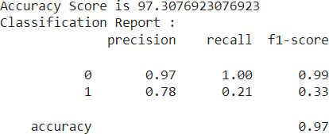

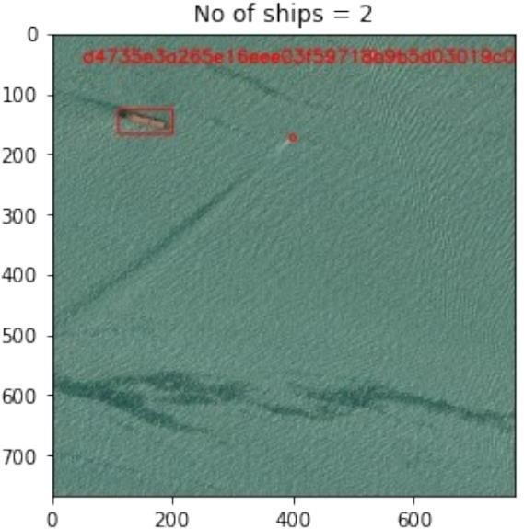

Fig.7. Performance of the model.

**Result:**

Fig.8. describes the scenario 1, the satellite image does not have any ships in them, so the output is displayed as below, there are 0 ships so count function displays the value of 0. As there is no ship that’s why the hashing does not work.

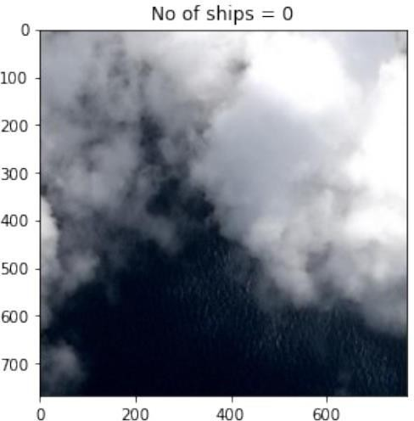

Fig. 8. No ships in the satellite image

The shape of the image which we want as an output the function returns the value of X-axis, Y-axis, breadth and height with the bounding box is going to be drawn on the image which helps us to spot the ship on the image.

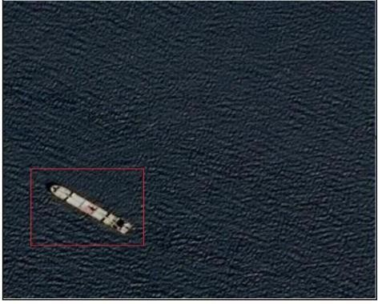

Fig.9. Detection of ship from the satellite image.

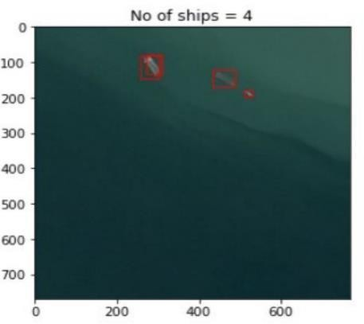Next step we have tried to count the no of ships that are in the image. The algorithm is further extended to count ships that are in the image.

Fig.10.How the ships are counted and displayed on the top of the image.

One of the safest and most difficult to crack algorithms, the SHA-512 algorithm, is used to generate the hashing value. Using a brute force strategy, it would take 2^256 time to decode the hash value without the key.

Fig.11. Hashing Value along with Count of ships

X-axis: bounding box width

Y-axis: bounding box height

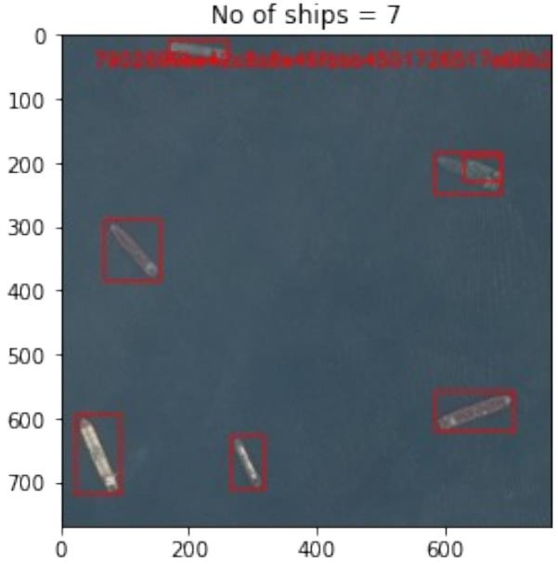 The implementation of hashing is done numerous real time applications, where locating missing ships and preventing trafficking of illicit commodities.

Fig.12. Another picture hashing Value along with Count of ships.

X-axis: bounding box width

Y-axis: bounding box height

Since hashing is unique and irreversible, it is desirable to utilize it with the model. Since all of the SAR data originates from satellites and is initially centralized, it might become a potential target and be readily attacked if security mechanisms are not implemented to safeguard it. Thus, to guarantee secure data, effective algorithms are employed.

***IV CONCLUSION AND FUTURE SCOPE***

In the paper a secure enhanced way to identifying of ships using the deep learning approach has been done, the data which we have performed operations is all real time data and with this we can say that it works accurately for any type of images like cloud, land masked and high resolution, over any climatic data.

By the utilization of YOLOV3 algorithm and its multilevel feature extraction and identification helps us to detect the images at three levels which are small, medium and large. And the rel2bbox help us to identify the area where the ships are present which can be located by looking at the rectangular box.

Normalization has been done in order to remove the duplicate values and also for the bounding box area which less than 1 percent so that the accuracy and effectiveness is improved and processed time also reduced.

Furthermore, this model is also works for the user data if the user gives the input of images and the backend code will process and gives the output as it is required. The usage of SHA-512 algorithm gives the integrity and security to the loc of the ship and count of the ships so that they remain confidential.

***V REFERENCES***

[1] Nie, X. et.al, Yang, M., & Liu, R. W. Deep neural network-based robust ship detection under different weather conditions. In 2019 IEEE Intelligent Transportation Systems Conference (ITSC) (pp.47- 52).IEEE. (2019, October).[<https://ieeexplore.ieee.org/abstract/document/8917475>]

[2] Rong, H. et.al, Ramirez-Serrano, A., Guan, L., & Gao, Y. Image object extraction based on semantic detection and improved K-means algorithm. IEEE access, 8171129171139.(2020)[<https://ieeexplore.ieee.org/abstract/document/9200601>]

[3] Li, H. et.al , Deng, L., Yang, C., Liu, J., & Gu, Z. Enhanced YOLO v3 tiny network for real-time ship detection from visual image. Ieee Access, 9,16692- 16706 (2021)[<https://ieeexplore.ieee.org/abstract/document/9334973>]

[4] Wang, Y. et.al Rajesh, G., Mercilin Raajini, X., Kritika, N., Kavinkumar, A., & Shah, S. B. H. Machine learning-based ship detection and tracking using satellite images for maritime surveillance. Journal of Ambient Intelligence and Smart Environments, 13(5),361371.(2021)[[https://content.iospress.com/articles/journal-of-ambient-intelligence-and-senvironments/ais210610](https://content.iospress.com/articles/journal-of-ambient-intelligence-and-smart-environments/ais210610)]

[5] Hong et.al, Z. et.al, Yang, T., Tong, X., Zhang, Y., Jiang, S., Zhou, R., ... & Liu, S. Multi-scale ship detection from SAR and optical imagery via a more accurate YOLOv3. IEEE Journal of Selected Topics in Applied Earth Observations and Remote Sensing, 14, 6083-6101.(2021). [<https://ieeexplore.ieee.org/abstract/document/9448440>

[6] Gadamsetty, S. et.al, Ch, R., Ch, A., Iwendi, C., & Gadekallu, T. R. Hash-based deep learning approach for remote sensing satellite imagery detection. Water, 14(5), 707. (2022)[https://[www.mdpi.com/2073-4441/14/5/707](http://www.mdpi.com/2073-4441/14/5/707)]

[7] Van de Sande, K. E. et.al , Uijlings, J. R., Gevers, T., & Smeulders, A. W. Segmentation as selective search for object recognition. In 2011 international conference on computervision(pp.18791886).IEEE.(2011,November).

[<https://ieeexplore.ieee.org/abstract/document/6126456>]

[8] Hannevik, T. N. et.al , Olsen, Ø., Skauen, A. N., & Olsen, R. Ship detection using high resolution satellite imagery and space-based AIS. In 2010 International Water Side Security BY Conference (pp.1-6). IEEE.(2010,November). [[https://ieeexplore.ieee.org/abstract/document/5730](https://ieeexplore.ieee.org/abstract/document/5730248) [248](https://ieeexplore.ieee.org/abstract/document/5730248)]

[9] Zou, L. et.al, Zhang, H., Wang, C., Wu, F., & Gu, F. Mw-acgan: Generating multiscale high-resolution SAR images for ship detection. Sensors, 20(22), 6673.

[10] Chen, X. et.al,Xiang, S., Liu, C. L., & Pan, C. H. Aircraft detection by deep belief nets. In 2013 2nd IAPR (2020). [<https://www.mdpi.com/1424-8220/20/22/6673>]

Asian Conference on Pattern Recognition (pp. 54- 58).IEEE.(2013,November).[<https://ieeexplore.ieee.org/abstract/document/6778281>]